

How Distractions Turn a Clear CX Vision into a Growing Customer Problem
At a conference, a striking image made the point without a management framework: a person can remain pointed toward a meaningful destination while gradually collecting burdens that make forward movement impossible. Customer-experience programmes fail this way—not through one dramatic rejection of the vision, but through sensible-looking interruptions that accumulate until nobody is working on the customer problem that mattered most.
Consider a familiar composite case. A financial-services firm set out to make applying for a credit card simple, transparent and largely digital. Eighteen months later, its teams had delivered campaign landing pages, call-centre scripts, dashboard upgrades, a chatbot pilot and several branch workarounds. Conversion had barely improved. Repeat contacts rose. No one had stopped caring; the programme had simply become too busy to see what it was carrying.

The problem grew while everyone was being helpful
The original issue was straightforward: applicants were abandoning the process after submitting documentation, uncertain whether their application had been received, what would happen next, or how long approval would take.
Then the distractions arrived.
- Marketing needed a faster response to a competitor’s offer.
- Operations asked for help reducing calls.
- Compliance needed revised disclosures.
- Technology proposed a platform upgrade.
- Branch leaders wanted a tailored process for high-value customers.
Each request was defensible in isolation. None required a team to explain what work would stop, which customer outcome it would improve, or whether it addressed the failure customers were actually experiencing.
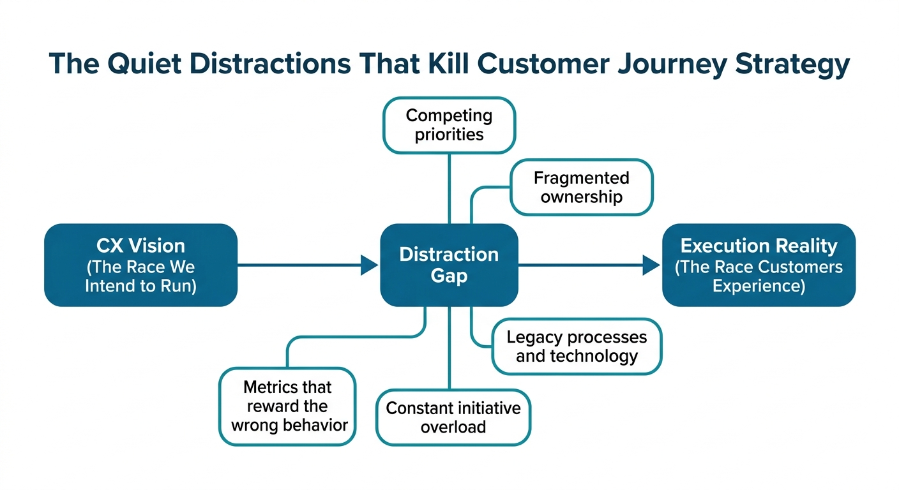
Figure 1. Distraction gaps widen the divide between CX vision and execution reality
This is how a journey becomes fragmented. Teams start using labels such as “digital acquisition,” “branch sales” and “credit approval,” treating them as separate work while customers experience one continuous attempt to obtain a card.
In a comparable banking example, consolidating these disconnected initiatives into “Apply for and Acquire a Credit Card” exposed overlapping ownership, competing priorities and duplicate investment [8]. The naming decision is not cosmetic: it determines who is accountable, which metrics matter and what work is allowed to compete for funding [2][7].
The danger is not that leaders approve the wrong initiative once. It is that the organisation silently converts a strategic journey team into an internal response unit. It gets praised for being responsive while the underlying failure keeps expanding.

Separate a real interruption from a strategic detour
A mature CX function should not reject urgent work automatically. A major outage, a safeguarding concern, a regulatory obligation or a severe service failure deserves immediate attention. The discipline is to stop treating every request as the same kind of work.
Use three lanes:
- Protect: work that prevents immediate customer harm, legal exposure or material service breakdown.
- Repair: work that resolves a known journey failure with a confirmed cause.
- Improve: work that redesigns the journey so the failure is less likely to recur.
Most distractions are not invalid; they are simply unclassified. A senior request to “improve onboarding” may belong in Improve, but it should not displace a Protect item. A spike in calls may justify Repair, but only after checking whether calls stem from unclear communications, a broken hand-off, delayed fulfilment or a policy customers cannot understand.
The first practical intervention is a one-page intake rule. No initiative enters the journey roadmap without answering five questions:
- What customer problem are we solving, in the customer’s own terms?
- Where does it occur in the agreed journey?
- What evidence establishes its frequency, severity and affected population?
- What outcome will change if we act—and who owns that outcome?
- What current work will be delayed, reduced or stopped to make capacity available?
That sequence matters. A funding request should establish the customer problem and evidence before proposing a solution; otherwise, the preferred fix becomes the lens through which all evidence is interpreted [6]. UX discovery uses the same logic: frame and bound the problem before deeper research or design work begins [5].

Bring the growing problem back into view
In the credit-card example, the team initially believed customers abandoned because the application form was too long. The form was not elegant, but it was not the main cause. Investigation showed that applications requiring documents moved into a manual review queue. Customers received neither a confirmation nor a realistic status update. Call-centre agents could see only partial information. Branch staff created their own workarounds. The “conversion problem,” “contact-centre problem” and “branch problem” were one broken journey moment.
This is where a Journey Atlas earns its keep. It is not another artefact to admire. It is the governing inventory that lets leaders decide whether multiple projects belong to one customer journey, whether they duplicate investment and whether a journey has enough evidence and ownership to merit action [8].
Use a weekly decision forum—not a status meeting—to make the trade-offs visible. The Journey Owner brings the customer signal; operational, product, risk and technology leaders bring constraints and feasible options. The group makes one of four decisions: protect, proceed, pause or stop. Crucially, “proceed” must include an explicit displacement decision.
Do not let dashboard volume substitute for accountability. A metric without an owner, an action threshold and permission to change something is merely a more sophisticated distraction. CX storytelling is useful here because it translates journey evidence into a decision narrative for specific stakeholders, tying customer friction to business value and a concrete call to action [1].

Remove burdens from the operating model, not just the backlog
The solution is rarely “be more focused.” Focus has to be designed into roles, funding and routines.
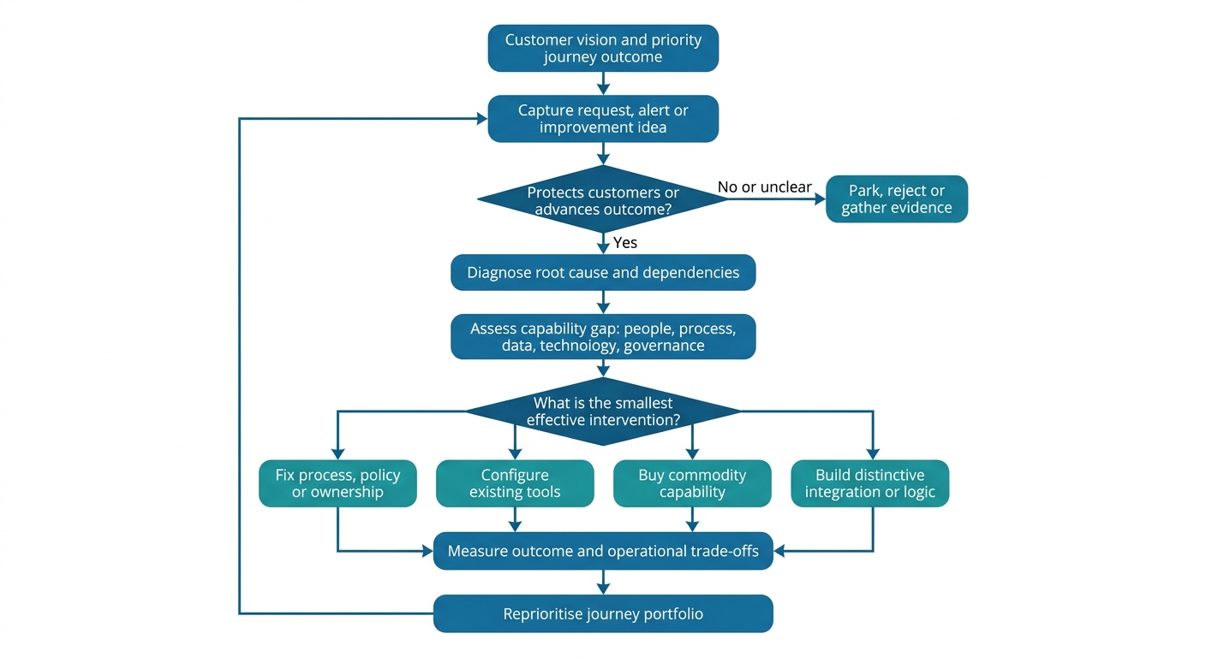
Figure 2. Turn the journey vision into a capability strategy

Capability needed | Already own | Missing / gap | Tool category | Implement (priority)
Agreed journey taxonomy and ownership | Partial maps | One governed definition and accountable Journey Owner | Journey governance repository | Now
Evidence-based intake and prioritisation | Ad hoc business cases | Common problem statement and displacement rule | Portfolio workflow | Now
End-to-end cause diagnosis | Channel metrics | Process, policy and system visibility | Journey analytics and service-blueprinting tools | Next
Decision-ready executive narrative | Reporting packs | Clear customer-to-value story | Data visualisation and presentation tools | Next
Frontline feedback and advocacy | Informal escalation | Safe route for staff to identify recurring friction | Voice-of-employee feedback tools | Later

The human test matters as much as the governance mechanics. Employees are more likely to advocate for the organisation when they understand the customer-first mission, feel empowered to act, take pride in customer success stories and would go out of their way to solve a customer problem [4]. If frontline staff are repeatedly asked to apologise for failures they cannot influence, no amount of journey messaging will create advocacy.
A leadership team should therefore ask a harder question each quarter: What have we deliberately stopped carrying? The answer reveals whether the organisation has protected its capacity to improve the journey—or merely become more efficient at managing the consequences of its distractions.

Sources
[1] Communication & Storytelling for CX.md — jlvm
[2][7] Journey_Naming_Is_Not_Semantics_Its_a_Governance_Decision_v3.docx — institute
[3][4] Journey to Customer Obsession- From Big Plans to Small Wins, One Journey at a Time V2.pdf — book
[5] Problem Statements in UX Discovery.md — jlvm
[6] CX_Funding_Request_Summary_INSTRUCTIONAL_Template V2.docx — book
[8] The Journey Atlas .docx — book
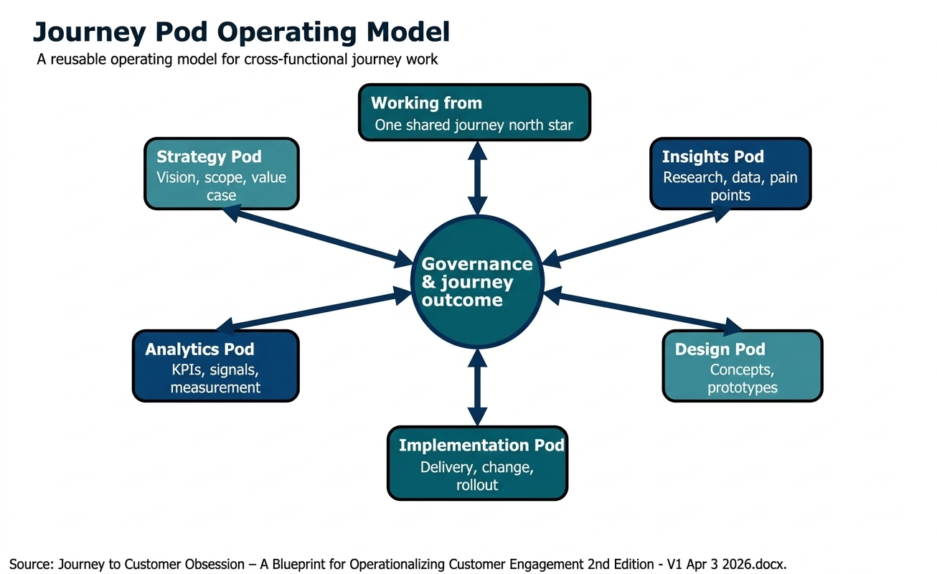
Source: Journey to Customer Obsession – A Blueprint for Operationalizing Customer Engagement 2nd Edition - V1 Apr 3 2026.docx

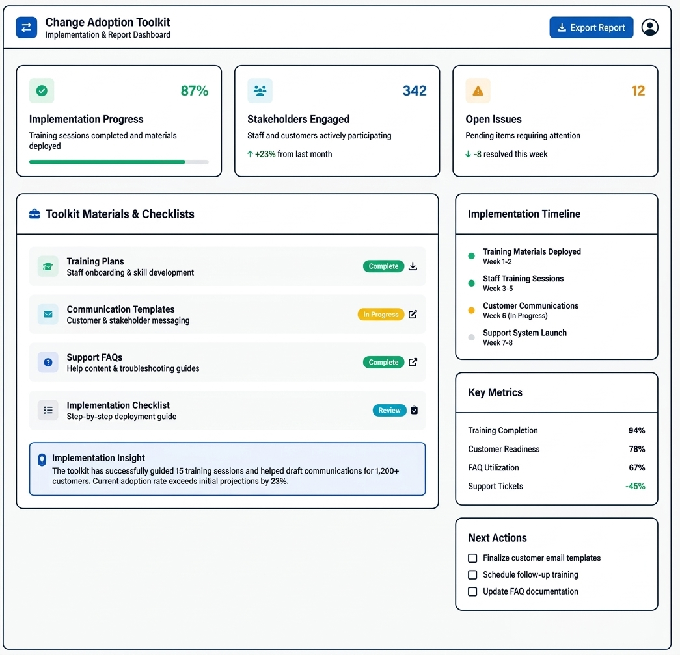
Source: Journey to Customer Obsession- From Big Plans to Small Wins, One Journey at a Time V2.pdf

